**Absolute Trip Delays**

***Work-flow to Use Absolute Trip Delays***

Use **Load Template** to set up and modify the preference for a several conditions



Repeat **Load Template** for additional instances of any template



***Preference Overview***

This preference sets a maximum overlap time of two adjacent trips and an associated penalty for allowing overlap. The penalty increases with the overlap time, from 1 min. to the maximum you set.

A real-life schedule with trip overlaps is generally, feasible. The preference is intended for testing "What if?" scenarios. For example, if the Duties, Vehicles and Operating Cost KPIs show a significant improvement there might be a case for relatively small manual adjustments to the Vehicles schedule as illustrated in the example below.

***Templates Available from Optibus***

*Table 1-1: Templates Summary*

|  |  |  |
| --- | --- | --- |
| **Template Name** | **Purpose** | **Reference** |
| Overlap - general | Sets a maximum overlap time for two adjacent trips and an associated penalty for allowing overlap. The penalty increases with the overlap time, from 1 min. to the maximum. | **Overlap - general** |
| Overlap - for route group | Sets a maximum overlap time for two adjacent trip and an associated penalty for allowing overlap for a nominated route group. The penalty increases with the overlap time, from 1 min. to the maximum. | **Overlap - for route group** |

***Overlap - general***

**Purpose:**

Sets a maximum overlap time for adjacent trips and an associated penalty for allowing overlap. The penalty increases with the overlap time, from 1 min. to the maximum.

**Prerequisites:** None.

**Opening Dialog:**

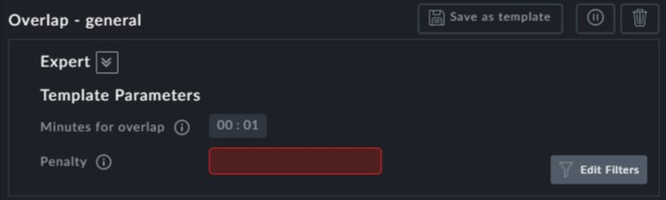

**Points to note:**

**Penalty**: The Penalty field is mandatory. The penalty determines the importance of **not**

having these overlaps. As the penalty increases the number of overlaps decreases.

**Example:**

Here is a segment of a Vehicle Gantt for the example:

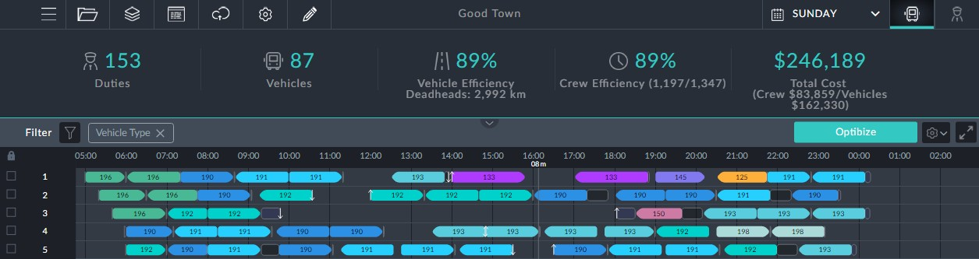

We will allow an overlap on 10 minutes with a penalty of 20 for interurban trips. Here is the same segment after optimization:

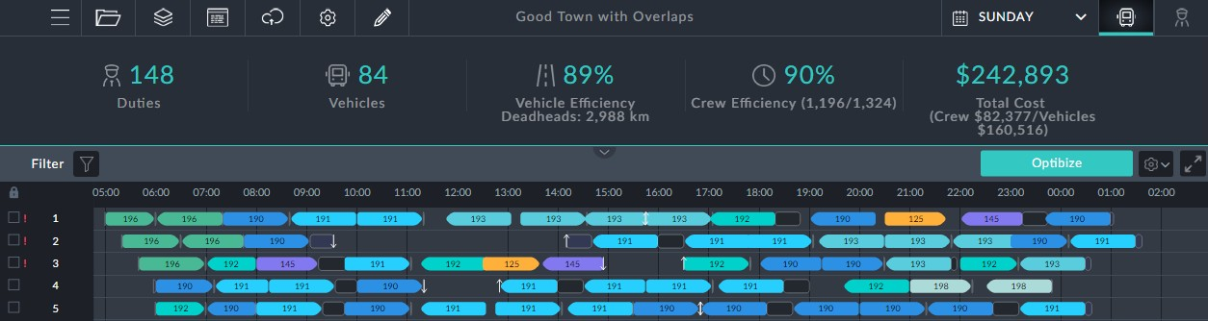

Notice red exclamation marks to the left most of the blocks. It indicates overlaps. If for

example we click block 3, the information box tells us what has happened:

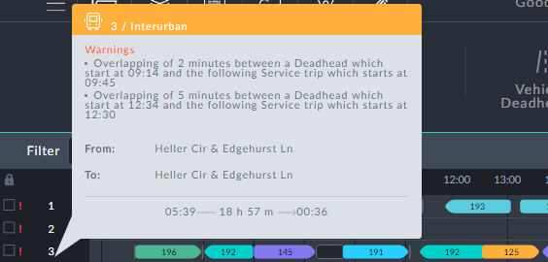

The first deadhead is a return to depot and driver stand-down. We may be able to move it by 2 min. The second deadhead cannot be altered.

All in all, checking each block is a pains-taking activity- however the savings indicated by the KPIs might make it worthwhile.

***Overlap - for route group***

**Purpose:**

Sets a maximum overlap time for adjacent trips and an associated penalty for allowing overlap within a nominated route group. The penalty increases with the overlap time, from 1 min. to the maximum.

**Prerequisites:** You should have already defined your route groups. See Miscellaneous

Assignments, **Route Groups**.

**Opening Dialog:**

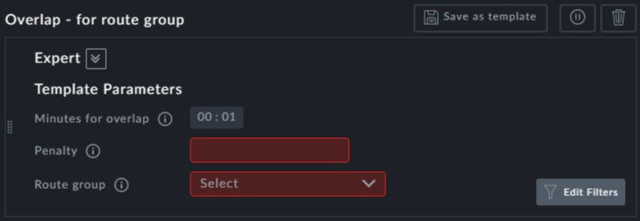

**Points to note:**

Both the **Penalty** and the **Route group** fields are mandatory.



To see the list of all the overlaps in the result schedule, you can download

the reports, and look at vehicle schedule or crew schedule reports, in the overlap column. See TBD.